**SQL project 1 submission by Sandhya Banti Dutta Borah**

1. Create a database named *employee*, then import **data_science_team.csv proj_table.csv** and **emp_record_table.csv** into the **employee** database from the given resources.

create database employee;

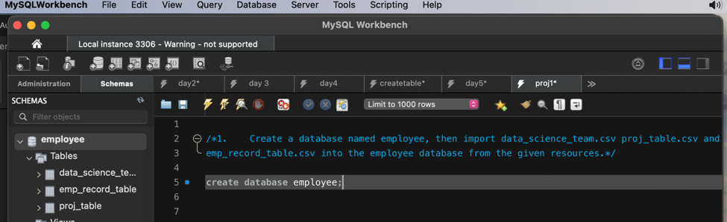

Ans of Q.1

1. Create an ER diagram for the given **employee** database.

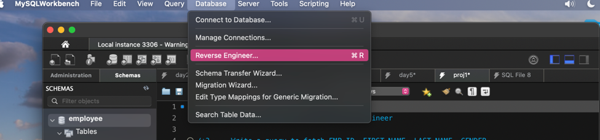

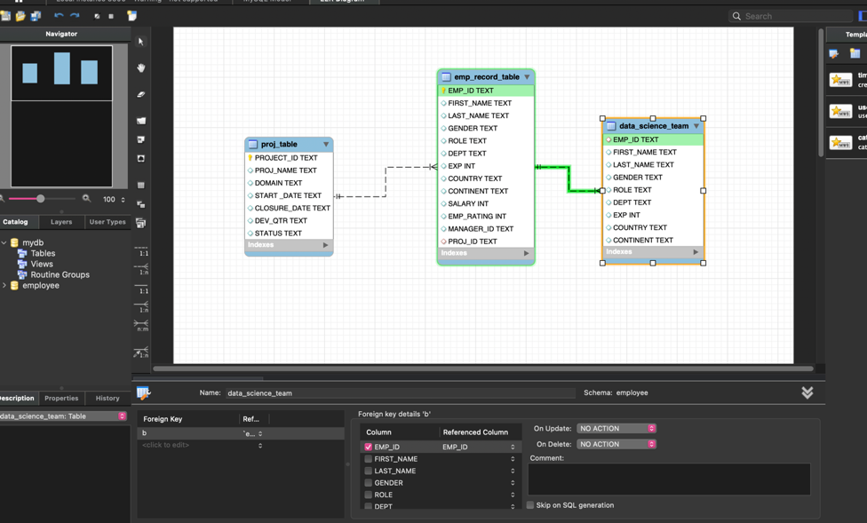

Ans to Q.2

1. Write a query to fetch EMP_ID, FIRST_NAME, LAST_NAME, GENDER, and DEPARTMENT from the employee record table, andmake a list of employees and details of their department.

select * from emp_record_table;

select EMP_ID, FIRST_NAME, LAST_NAME, GENDER, DEPT from emp_record_table;

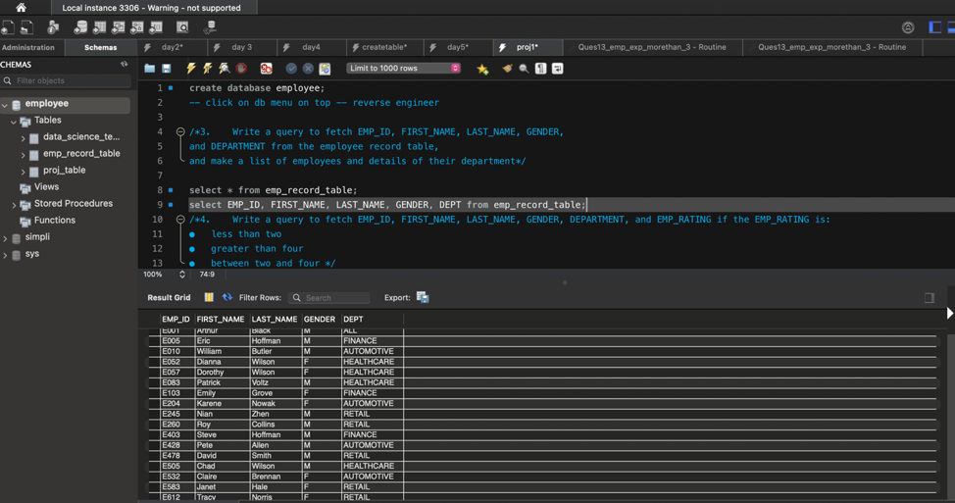

Ans to Q.3

1. Write a query to fetch EMP_ID, FIRST_NAME, LAST_NAME, GENDER, DEPARTMENT, and EMP_RATING if the EMP_RATING is:

* less than two
* greater than four
* between two and four

SELECT EMP_ID, FIRST_NAME, LAST_NAME, GENDER, DEPT, EMP_RATING

FROM emp_record_table

WHERE EMP_RATING < 2;

SELECT EMP_ID, FIRST_NAME, LAST_NAME, GENDER, DEPT, EMP_RATING

FROM emp_record_table

WHERE EMP_RATING > 4;

SELECT EMP_ID, FIRST_NAME, LAST_NAME, GENDER, DEPT, EMP_RATING

FROM emp_record_table

WHERE (EMP_RATING >=2 and EMP_RATING<4);

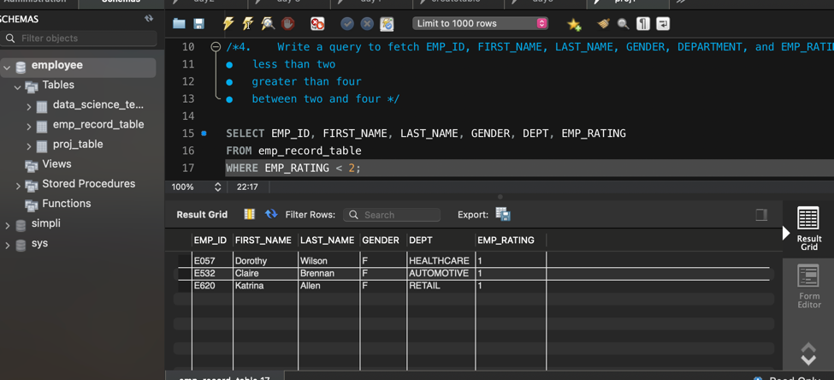

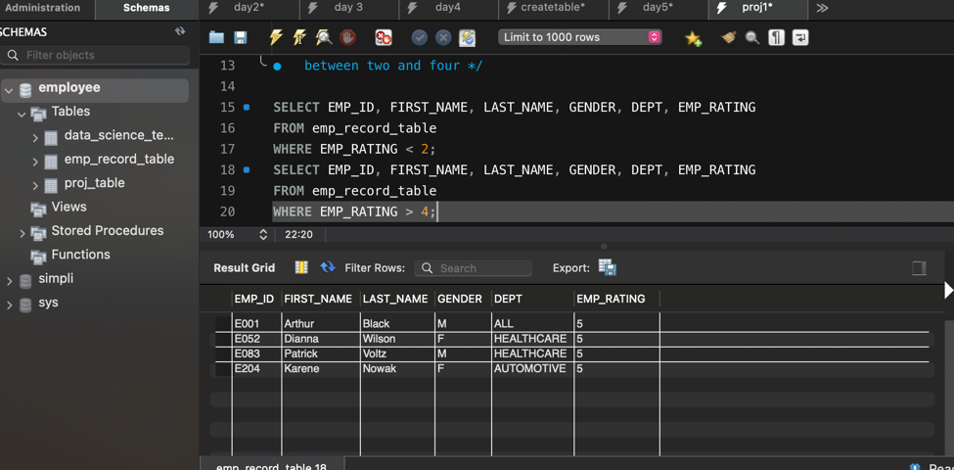

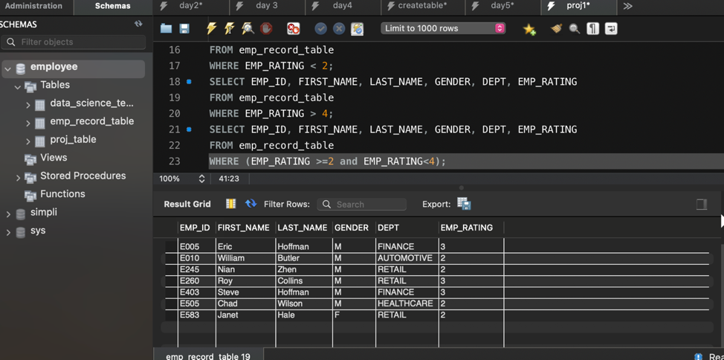

Ans to Q.4

1. Write a query to concatenate the FIRST_NAME and the LAST_NAME of employees in the *Finance* department from the employee table and then give the resultant column alias as NAME.

select FIRST_NAME, LAST_NAME, concat(FIRST_NAME," ", LAST_NAME)

as fullname from emp_record_table as NAME

where DEPT= 'FINANCE';

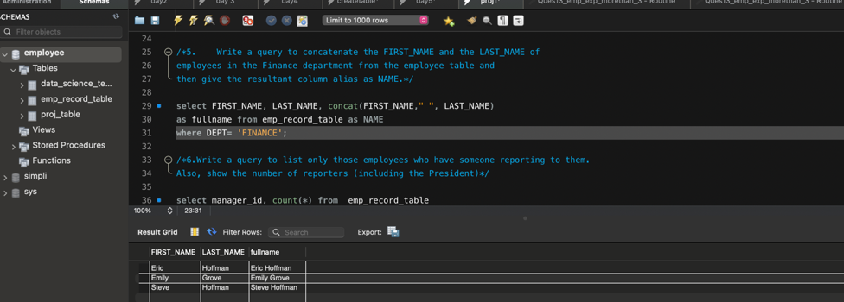

Ans to Q.5

1. Write a query to list only those employees who have someone reporting to them. Also, show the number of reporters (including the President).

select manager_id, count(*) from emp_record_table

group by manager_id;

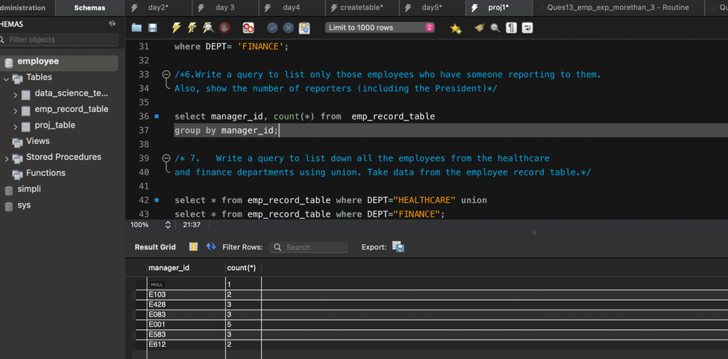

Ans to Q.6

1. Write a query to list down all the employees from the healthcare and finance departments using union. Take data from the employee record table.

select * from emp_record_table where DEPT="HEALTHCARE" union

select * from emp_record_table where DEPT="FINANCE";

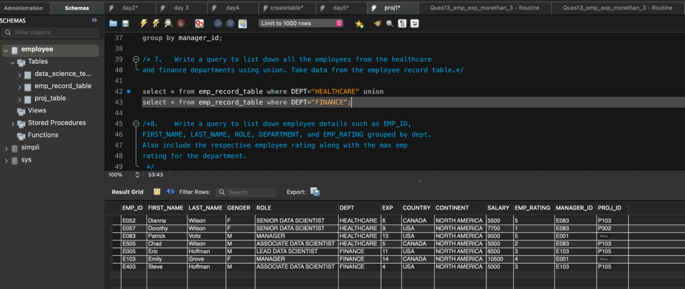

Ans to Q.7

1. Write a query to list down employee details such as EMP_ID, FIRST_NAME, LAST_NAME, ROLE, DEPARTMENT, and EMP_RATING grouped by dept. Also include the respective employee rating along with the max emp rating for the department.

SELECT

EMP_ID, FIRST_NAME, LAST_NAME, ROLE, DEPT, EMP_RATING,

Max(EMP_RATING) over(partition by dept) as max_Emp_rating

FROM

emp_record_table;

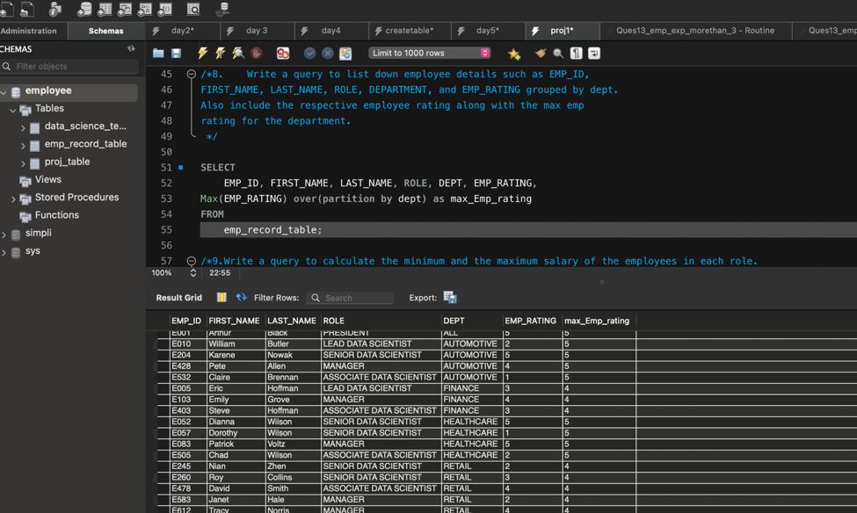

Ans to Q.8

Q.9. Write a query to calculate the minimum and the maximum salary of the employees in each role. Take data from the employee record table.

select *, min(salary) over(partition by role) as min_sal,max(salary) over(partition by role) as max_sal

from emp_record_table;

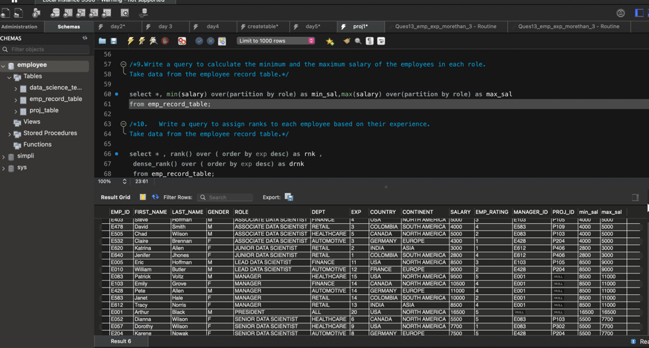

Ans to Q.9

Q.10. Write a query to assign ranks to each employee based on their experience. Take data from the employee record table.

select * , rank() over ( order by exp desc) as rnk ,

dense_rank() over ( order by exp desc) as drnk

from emp_record_table;

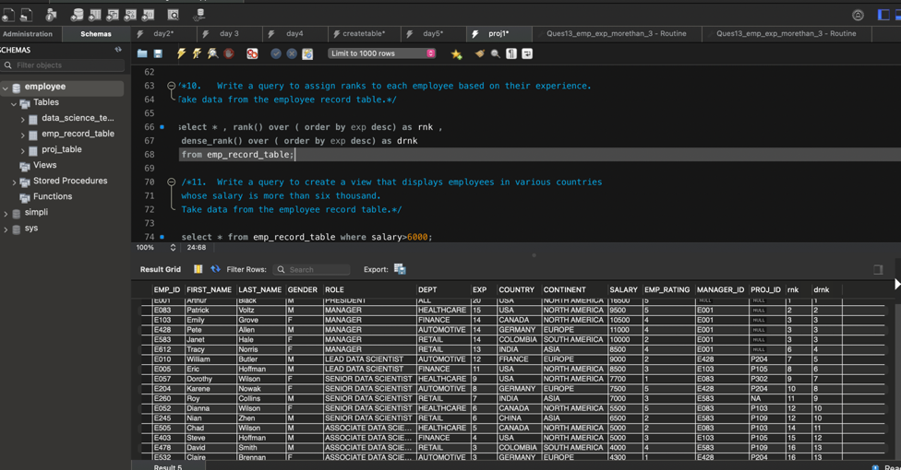

Ans to Q.10

Q.11. Write a query to create a view that displays employees in various countries whose salary is more than six thousand**.** Take data from the employee record table.

select * from emp_record_table where salary>6000;

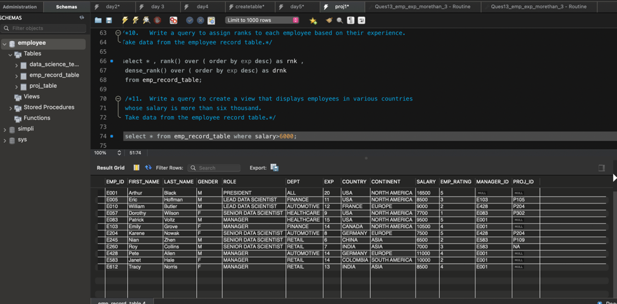

Ans to Q.11

Q.12. Write a nested query to find employees with experience of more than ten years. Take data from the employee record table.

select * from emp_record_table where emp_id= (select emp_id from emp_record_table where exp>10);

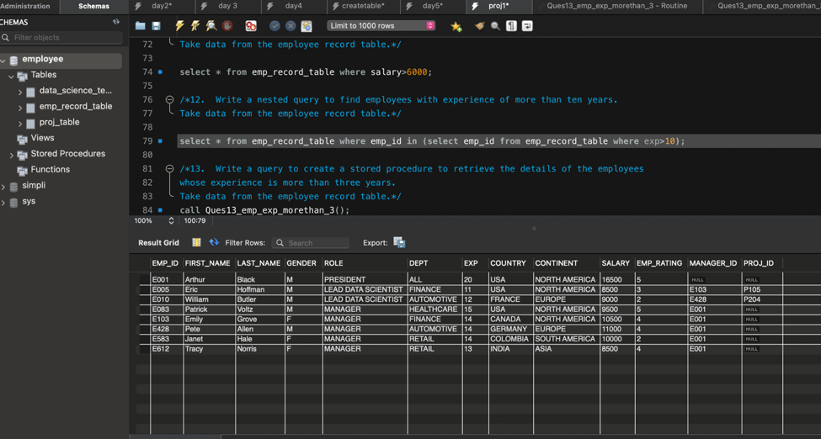

Ans to Q.12

Q.13. Write a query to create a stored procedure to retrieve the details of the employees whose experience is more than three years. Take data from the employee record table.

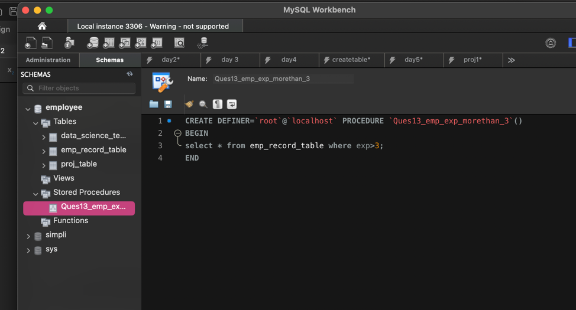

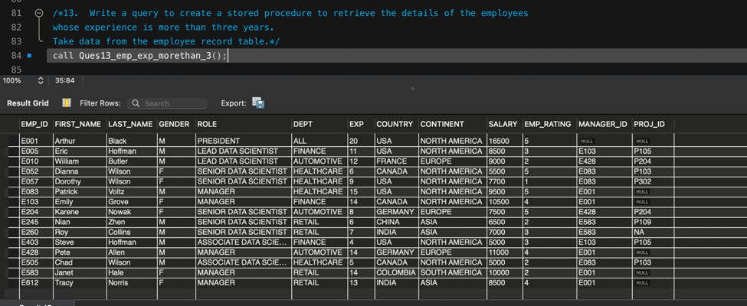

Ans to Q.13

Q.14. Write a query using stored functions in the project table to check whether the job profile assigned to each employee in the data science team matches the organization’s set standard.

The standard being:

For an employee with experience less than or equal to 2 years assign 'JUNIOR DATA SCIENTIST',

For an employee with the experience of 2 to 5 years assign 'ASSOCIATE DATA SCIENTIST',

For an employee with the experience of 5 to 10 years assign 'SENIOR DATA SCIENTIST',

For an employee with the experience of 10 to 12 years assign 'LEAD DATA SCIENTIST',

For an employee with the experience of 12 to 16 years assign 'MANAGER'.

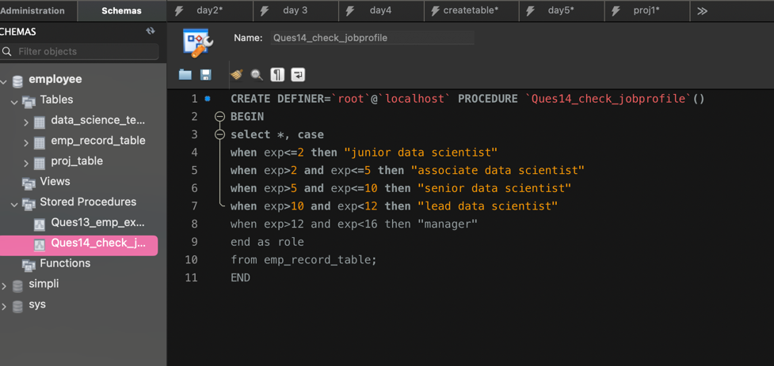

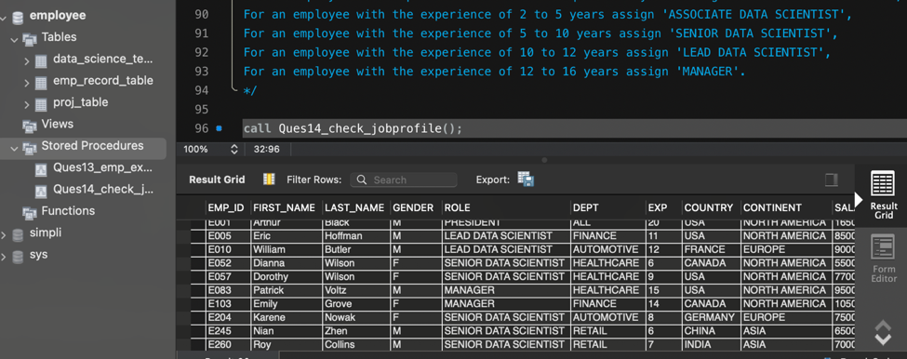

Ans to Q.14

Q.15. Create an index to improve the cost and performance of the query to find the employee whose FIRST_NAME is ‘Eric’ in the employee table after checking the execution plan.

Create index i1 on emp_record_table(FIRST_NAME);

Show indexes from emp_record_table;

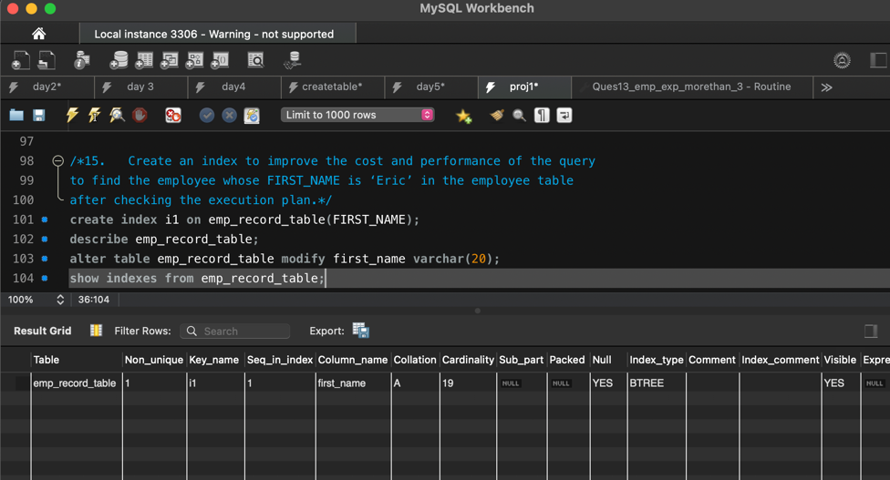

Ans to Q.15

Q.16. Write a query to calculate the bonus for all the employees, based on their ratings and salaries (Use the formula: 5% of salary * employee rating).

Select emp_id, (salary *0.05) *emp_rating as bonus from emp_record_table;

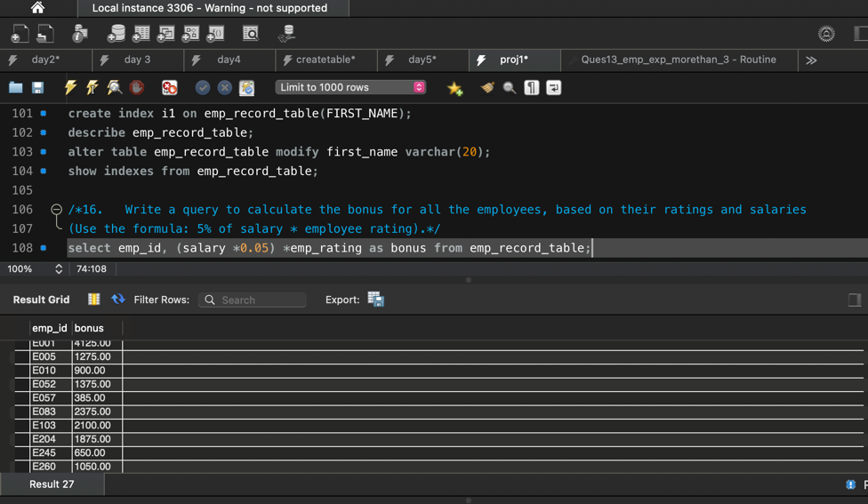

Ans to Q.16

Q.17. Write a query to calculate the average salary distribution based on the continent and country. Take data from the employee record table.

Select *, avg(salary) over(partition by country), avg(salary)over(partition by continent) from emp_record_table;

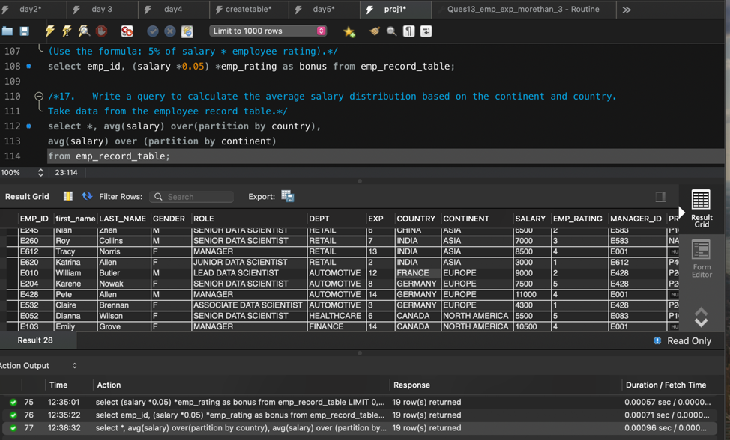

Ans to Q.17